Table of Contents

PURPOSE 3

SAFETY INFORMATION AND RISK ASSESSMENTS 3

Personal Protective Equipment (PPE)/Control Measures 3

Risk Assessments 3

PROCEDURE 4

IMPORTANT AMENDMENTS DUE TO IMPLEMENTATION OF BLOODTRACK AND ICE 4

ICE GENERATED REQUESTS FOR TRANSFUSION 4

REQUEST USING MRN: APPLICABLE TO MUSGROVE SITE ONLY 4

‘ON DEMAND’ SAMPLE LABELS PRINTED AT PATIENT BEDSIDE ACCEPTABLE ON SAMPLES 5

Step 1. Prioritise work 5

Step 2. Confirm form and sample meets sample acceptance criteria 7

Step 3. Request on LIMS 11

• ICE request 11

• Non ICE request 12

Printing label for sample and/or form 12

Selection of correct category 13

HANDLING OF SAMPLE REJECTS 13

**Rejected requests at original sample entry** 13

**Rejecting requests due to failure at demographic check stage** 16

Step 4. Centrifuge 17

REGISTERING A PATIENT ON WPE 17

Step 1: Check that a new registration is necessary 17

Step 2: For SMTC patients confirm details to be registered are correct on NHS Spine 17

Step 3: For Non SMTC patients decide if it is clinically necessary to process the sample immediately 18

Step 4: Actions required if deemed necessary to register a new patient 18

PERFORMING DEMOGRAPHIC CHECK 19

RELEASING RESULTS FROM BT ANALYSER 19

DETERMINING IF TWO SAMPLES ARE REQUIRED 19

DETERMINING IF TWO SAMPLES REPRESENT SEPARATE VENESECTION EVENTS 20

‘COLLECT’ LABEL SPECIFIC ACCEPT V’S REJECT CRITERIA 20

USE OF CONCESSION FORM (TXF83) 21

|  |  |
| --- | --- |
| **Associated Documents Stored in Q-Pulse**  (Please Indicate below which documents are stored in Q-Pulse with this procedure) (Q-Pulse No or N/A) | |
| **Bench Card** | **TXS9B** |
| See Q-Pulse record for Author, Activation & Revision Dates & Document History | |

# PURPOSE

All samples received are labelled with a WPE number (in format YYT……., for example 24T10000433), this can be generated on ICE when being requested by the ward, or will be generated by WPE when booking in in the laboratory

This SOP should be used and read in conjunction with ‘SPS Sample acceptance policy for Service Users, GGM1 , SPS Sample acceptance Policy for Laboratory use GGM2, Request form – Transfusion/Antenatal QMS11

# SAFETY INFORMATION AND RISK ASSESSMENTS

## Personal Protective Equipment (PPE)/Control Measures

|  |  |
| --- | --- |
| **Control Measures**  (Please remove any that are not applicable) | **Comments**  (When and how are these used?) |
| **Laboratory Coats** |  |
| **Gloves** |  |
| **Hand Hygiene** |  |

## Risk Assessments

|  |  |
| --- | --- |
| **Assessments**  (Please remove any that are not applicable) | **Maximum risk score (providing SOP and any control measures followed)** Risk Score - Low (1 to 6), Medium (8 – 12), High (15 – 25) |
| **Laboratory Equipment** | Low |
| **Laboratory Sharps** | Low |
| **Laboratory Chemical & Reagents** | Low |
| **Handling and Disposal of Clinical/Infected Material** | Low |
| **Transport of Clinical Material** | Low |
| **Premises and Working Environment** | Low |
| **Fire** | Low |
| **Lifting and Handling** | Low |
| **Transport & Disposal of Confidential Material** | Low |
| **Display Screen Equipment** | Low |

*See SPS Risk Register in Q-Pulse for list of all SPS risk assessments*

# PROCEDURE

## IMPORTANT AMENDMENTS DUE TO IMPLEMENTATION OF BLOODTRACK AND ICE

### ICE GENERATED REQUESTS FOR TRANSFUSION

The clinical areas can use ICE to generate requests, including Transfusion. This includes routine tests and also blood and blood product requests. Note Neonatal (Baby) group and Kleihauer can only be requested if patient demographic is applicable to that test

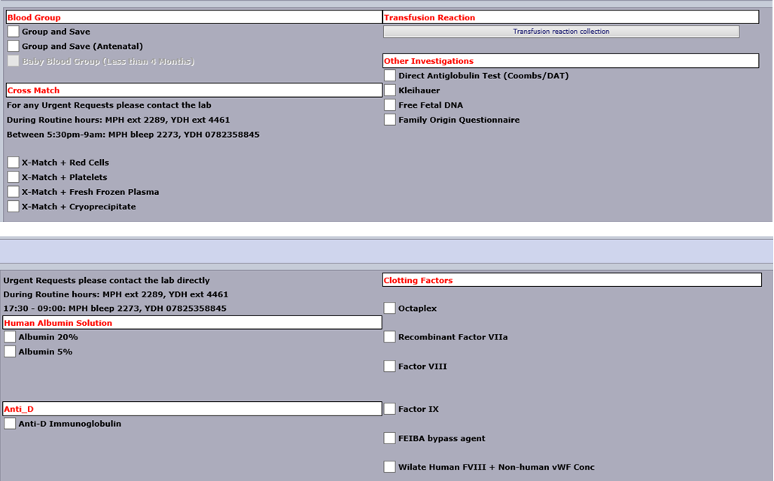

An ICE generated request will come with an ICE label on the form, but sample must still be handwritten (or can be a Blood Track Collect label (see later section)

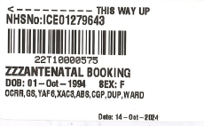ICE label – Form ONLY

### REQUEST USING MRN: APPLICABLE TO MUSGROVE SITE ONLY

For scanning of patient identification 2D barcodes printed on the compatibility label and linking this up with the patient wristband it is important that all group and screens which may lead to a request for blood or blood components are requested using the hospital number (Medical Record Number or MRN) . This applies even if the hospital number is NOT used on the sample.

For all requests which may lead to a component issue:

* If MRN is on the sample use this to request the sample
* If NHS number is on the sample and both MRN and NHS is on the form confirm that NHS number is correct but use the MRN (from form) to request the sample
* **If NHS number is on the sample and form and MRN is not on form it will be necessary to look up the patient record on LIMS, write down the MRN from the patient record and then use this to request the sample**

**The Transfusion Team appreciate that this is a deviation from previous process but is necessary to ensure that any component issued can have label verification performed before release to the issue fridge and can be transfused to the patient without an alert sounding on BloodTrack which prevents it being transfused via BloodTrack.**

NB: This is not applicable to Antenatal requests which do not lead to component issue

NB: This is not applicable to Yeovil where NHS number is used on the patient wristband and therefore is the MRN

## ‘ON DEMAND’ SAMPLE LABELS PRINTED AT PATIENT BEDSIDE ACCEPTABLE ON SAMPLES

At Musgrove Park Hospital only BloodTrack TX can be used to generate labels for blood transfusion sample tubes. A handheld PDA device is used to scan the patient wristband and this information is used to print a label for the sample tube as one continuous process at the patient bedside. The collect label will therefore always match the patient wristband, however, if the details on the collect label don’t match WinPath it is important to ascertain the correct details – the clinical area should be asked to reprint the wristband and repeat bloods if this if confirmed to be incorrect

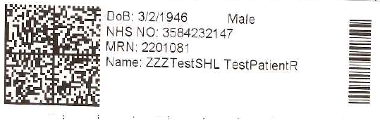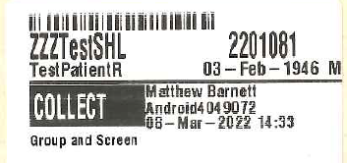 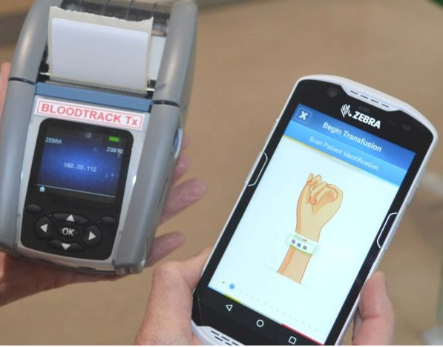

Patient wristband

Label for sample tube – Note ‘COLLECT’ field detailing who collected and date and time. This information is held on BloodTrack and is fully auditable

Bedside PDA and printer

These labels contain all the required details and are acceptable on the sample tube. There is no requirement to handwrite any additional information on the sample tube. ***There should be no alterations on the collect label. Multiple labels printed at the same time can only be used to label tubes if they represent a single phlebotomy event.***

Not to be confused with normal ‘addressograph’ sample labels which are NOT acceptable on samples

Or ICE labels which are NOT acceptable on samples

## Step 1. Prioritise work

Check through received work and divide into Urgent, Priority and Routine so that samples are requested in correct order. Requests for blood (required in next 24 hours) same day surgery and FMH (Kleihauer) requests have higher priority than routine group and saves, which have priority over ‘POAC’ samples and Antenatal samples.

All Antenatals are sent to Musgrove Park for testing. At Yeovil ensure that ONLY Antenatals are sent (not Labour or Freya ward samples, or any patient who may require blood).

All requests at Musgrove Park should be checked for Yeovil samples which need to be sent back to Yeovil for processing (for example Queensway/Macmillan patients/PAC6A).

At Musgrove Park requests received during routine hours without a sample (blood and batch products requests) should be passed straight to the crossmatching bench were they will be requested separately to promote the flow of work through the laboratory.

Ensure you are using your own log-in for WPE. If unsure log-out the current user and log back in. For Clinical Governance reasons it is essential that the staff member performing the task is correctly identified. Ensure only one sample is labelled and requested at one time. The same individual must label and request the sample in one complete sequence. Discard any unused barcodes after each request.

**Note there may still be some older style forms in circulation.**

## Step 2. Confirm form and sample meets sample acceptance criteria

Check request form for essential elements (see below for current request form)

Complete all sections of the request form clearly & legibly – The form **MUST contain at least 4 points of identification including a unique identity number** (see SPS Sample acceptance policy for full details), ordercomms labels & patient note (addressograph) labels are acceptable on the request form but **must not be used on the sample. The exception are ‘on-demand’ Collect sample labels generated at the patient bedside by BloodTrack**

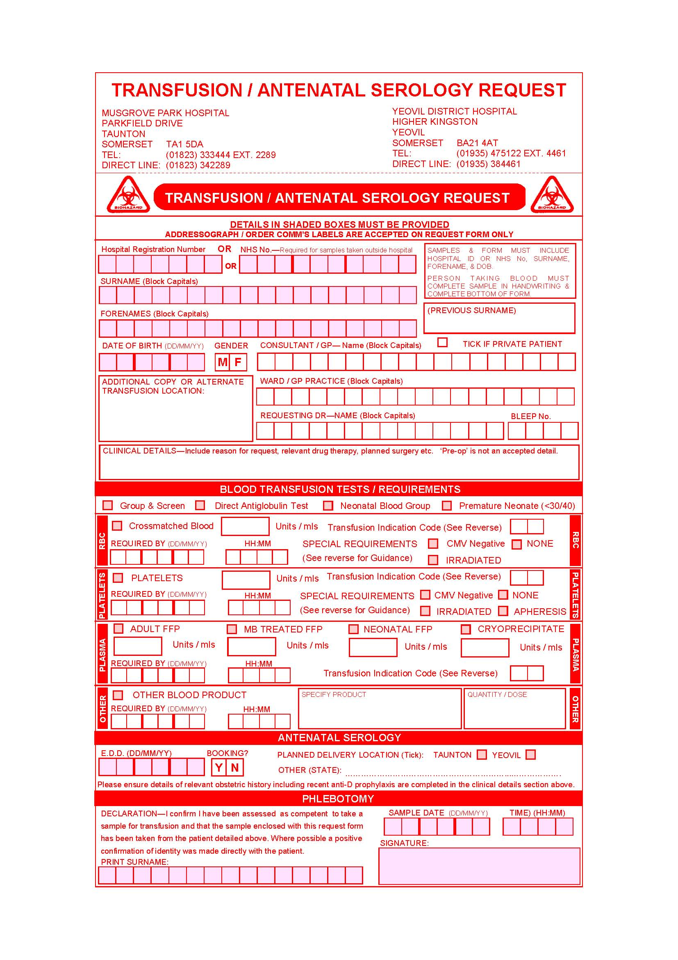

Ensure the **requesting Consultant/GP** is clearly indicated and the **location of the request / transfusion** has been given

If a **copy report** is required please give details here

Please indicate **relevant clinical details including the date of surgery** **if applicable**. This helps us to prioritise our work and inform you of potential problems

Please tick tests / products required & indicate **how many units, special requirements** & **when the products are needed**

Practitioner to complete – **Any requests that are not signed here will be discarded. The exception are samples collected using BloodTrack Collect where this information is recorded electronically**

Please specify **product requirements** here.

**Date & Time of collection** to be completed by the person taking the blood sample

Please specify **product requirements** here.

**Date & Time of collection** to be completed by the person taking the blood sample

**Date & Time of collection** to be completed by the person taking the blood sample

Please indicate **relevant clinical details including the date of surgery** **if applicable**. This helps us to prioritise our work and inform you of potential problems

**Date & Time of collection** to be completed by the person taking the blood sample

* Remove sample from specimen bag and check that sample and form are identical
* Ensure request complies with SPS Policy (GGM1 and GGM2).

The following should be considered when reviewing form/sample information:

**It is essential that the Transfusion sample is labelled with exactly the same details as the patient wristband, as it is the details on this wristband which MUST match exactly the compatibility label on any blood component or product issued by Transfusion**

**At MPH:** The patient wristband is generated via MAXIMS. Currently Maxims may be updated by NHS Staff so can take into account ‘preferred’ names as declared by the patient. In light of a recent incident where patient preferred surname was changed on PAS but wristbands were not reprinted from MAXIMS it is important to check that the demographics being used match patient wristband and that if name is changed in PAS that new wristband is printed, and old one discarded. Future Transfusion requests would then need to use this new name and previous sample would not be suitable.

**At YDH**: The patient wristband is generated via Trakcare, which is taken from the NHS Spine. The Trakcare number is a 7 digit ‘G’ number. The patient identification on the wristband, therefore matches NHS Spine record.

Pre-op assessment generate Transfusion requests on patients without a wristband and will sometimes still use the YDH ‘H’ Hospital number, however this should be discouraged, and the NHS number used instead.

|  |  |  |
| --- | --- | --- |
| **Essential information**  **Collect ( ‘on demand’ ) labels** | **Desirable information** | **Unacceptable**  **(requiring rejection)** |
| **‘On demand’ bedside generated sample label**    **This label contains all the information required and is generated directly from patient wristband using BloodTrack**  **Note: Handwritten signature on sample is NOT required**  **Note: Phlebotomy section of form does not need to be completed as these details are held on BloodTrack (but ideally is still completed)**  **Details of any products required , requestor, location and clinical indication must be on the form, unless this is provided via use of a separate ICE request label** | Source of request  (Ward/Clinical area)  Clinical details | Alterations to BloodTrack label (including time of collection) |
| Patient label /Addressograph label on sample – acceptable on FORM only |
| ICE label on sample- acceptable on FORM only |
| Somerset Nuffield ‘BARS’ labels are acceptable on the form and sample. These labels are generated at the bedside following venepuncture. A ‘TA’ number is generated which must be entered as an ‘EXT’ number onto WinPath. |  |
| **Essential information**  **Handwritten samples** | **Desirable information** | **Unacceptable**  **(requiring rejection)** |
| **The sample must be handwritten**, but the form may be labelled using a patient label (addressograph) or ICE label providing all essential information is given as below |  | Sample not handwritten |
| **Unique identifying number**  MRN (Musgrove number) essential at Musgrove for all requests that may lead to blood or component issue  **NHS number preferred at Yeovil**  Musgrove Park = Maxims (Musgrove) number  Yeovil = Trakcare (7 digit number ‘G’ number).  NB At YDH some outpatient samples may still arrive with 6 digit ‘H’ hospital numbers, but as this does not print on the wristband its use is to be discouraged. | Source of request  Requesting clinician  EDD (or weeks gestation) for antenatal requests.  Clinical details  Tests required | No Unique identifier (form or sample)  Incorrect spelling of surname/forename, abbreviations of names  Incorrect spelling of surname/forename, including abbreviations of names  No Signature of person taking blood (phlebotomy declaration)  No date of sample collection (obtained either from form or sample)  Crossed out or altered information where correct patient identity is questionable. (for example a different name has clearly been crossed out, as opposed to a correction of spelling of the same patient details) |
| **Surname (correctly spelt) (as it appears on NHS Spine)**  ‘Preferred’ names, or alternative surnames (for example married v’s maiden name) can only be accommodated if the NHS Spine has been updated |
| **Forename (as it appears on NHS Spine)**  ‘Preferred’ names, (for example Debbie v’s Deborah) can only be accommodated if the NHS Spine has been updated, and the hospital wristband has this preferred name |
| **Signature of person taking the blood, including date and time of sample collection**. This person does not have to be a Dr but must be aware that they are taking responsibility for the generation of a Transfusion request and sign the declaration |
| **Date of birth** |
| ICE label is acceptable and must be booked in using this Order.    Form must be signed by person taking the sample and sample handwritten |

Notes:

If a discrepancy in name is noted (for example LIMS says Brian Edward and sample says Edward or Eddie) check with patient/patient wristband and NHS Spine that this is the correct preferred name. If appropriate amend LIMS to the preferred name, adding a note to clinical note pad to record relevant information

Do not alter LIMS record unless you are absolutely sure data is correct. Data may be checked with the patient, GP surgery or using NHS Spine (Smart card). See also section below entitled ‘ Registering a new patient on LIMS’

Do not enter a new patient registration into LIMS unless absolutely necessary. See section below entitled’ Registering a new patient on LIMS’

Exceptions to the above are:

* 1. Vascular patients (ruptured AAA) transferred between Musgrove Park, Yeovil or Barnstaple hospital. These patients will be admitted directly to theatre and may not be registered or allocated a Hospital number before surgery. They may also not have an NHS number available to them.

(1st line of address **or Postcode** acceptable)

* 1. Officers (Marines) from 40 CDO (Norton Manor Camp) (40 CDO acceptable as address)
  2. Antenatal patients who have only just moved to this country and do not have an NHS number (this should be confirmed on the NHS Spine) (1st line of address acceptable)
  3. Neonates which have been delivered at home as they will not have an NHS or hospital registration number (MRN) yet. (1st line of address acceptable).

Once form and sample have been checked to ensure essential information has been completed proceed to Step 3

## Step 3. Request on LIMS

### ICE request

Form will come labelled with an ICE request number

Log into WPE. Select BT. Request Entry

Using barcode scanner enter the lab number , and then again in the  field

Check all demographics brought up match your patient sample. For an OCS order the clinician, source, clinical details will be completed. If the requestor has generated a request on a pregnant patient the EDD or weeks gestation will be completed. There may also be information in this line

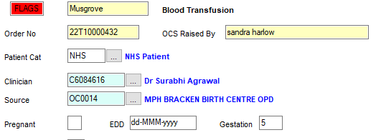

You will still need to choose the correct category and print a label for the sample (see later)

### Non ICE request

Log into WPE. Select BT: Request Entry



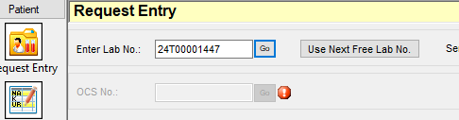

Use Next Free Lab No and Go. Next number will be assigned.

Enter Unique ID number (NHS or MRN) from the **sample** to search for the patient. Check all demographics match your patient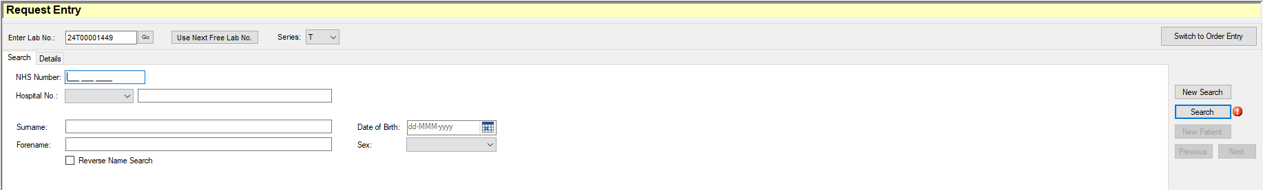

Check all demographics match your patient sample. You will need to complete all the highlighted fields, see below for details of category

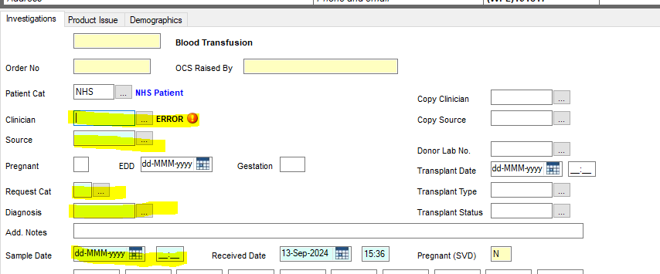



Once all fields have been completed (see below for details on Request category) click routine group and screen will be added (These do not need to be added by the requestor)

If you require additional tests (for example RHK, MONO, Neonatal DAT) they can be requested by putting the correct request code in the TESTS box. See Information Sheet TXA28 for list of request codes

### Printing label for sample and/or form

In requesting screen click icon at top 

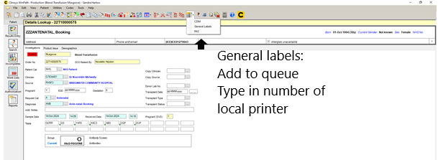

Printer number will be displayed on the ZEBRA printer. Two labels will print, attach to form and sample. If one label is not required discard it

## Selection of correct category

WPE uses request categories to determine which group and antibody screen TFC’s (request items) to add

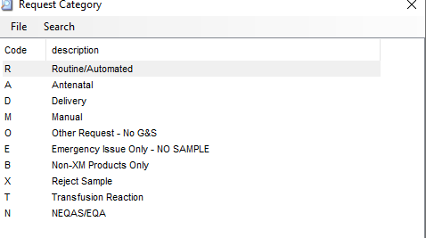

For routine group and screens the category is R, for antenatals it is A. For further details on Antenatal requesting refer to SOP TXS57

A different request category exists for delivery bloods, this is for the ‘Post Natal Fetal Leak’ requests only.

# HANDLING OF SAMPLE REJECTS

**Rejected requests at original sample entry**

If request fails sample acceptance policy it should be rejected. Request as per usual requesting procedure, choosing category X

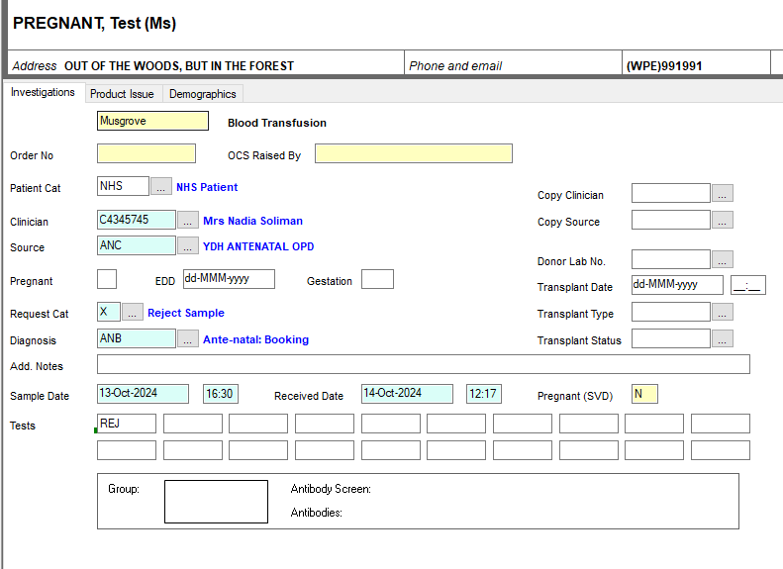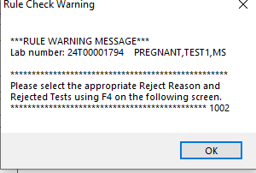

It will be necessary to perform demographic check (even though it has been rejected).

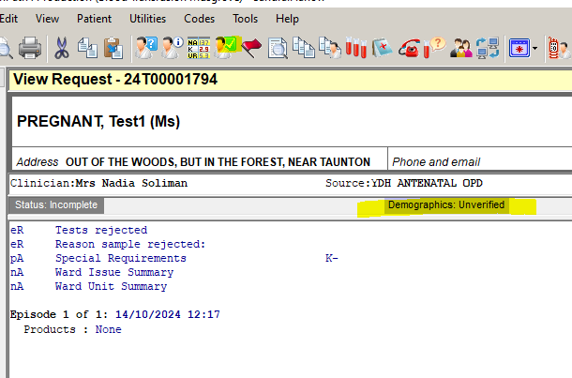

Click 

Then  to go into screen where you can put results in

In ‘Tests Rejected’ box either F4 to get list of test rejected or right click, Text validation table to get list

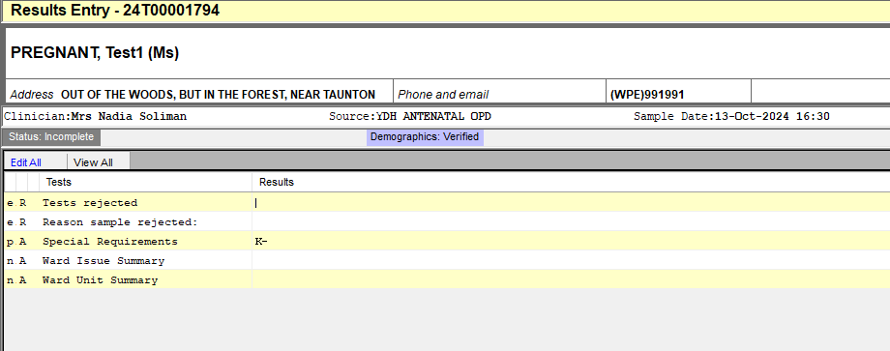

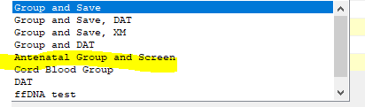

In Reason sample rejected line, either F4 or right click text validation table to get list

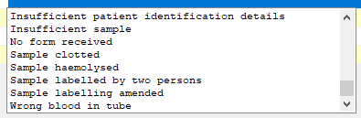

Select reason

You will then need to authorise via the failed queue/sample rejects

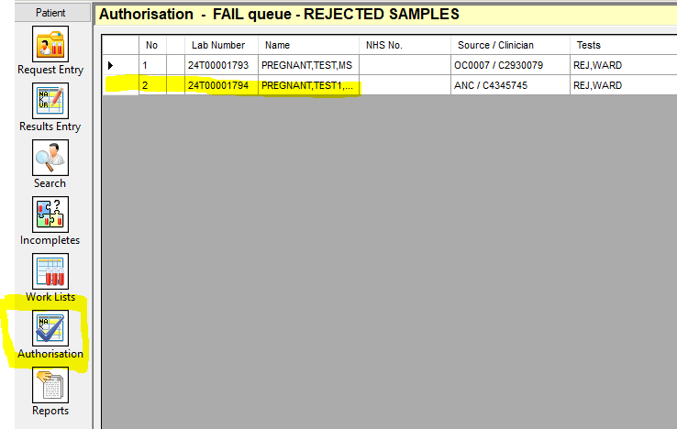

**Rejecting requests due to failure at demographic check stage**

If a sample needs to be rejected after it has been on the analyser in demographic verification screen click  and then add on the request item REJ and then  

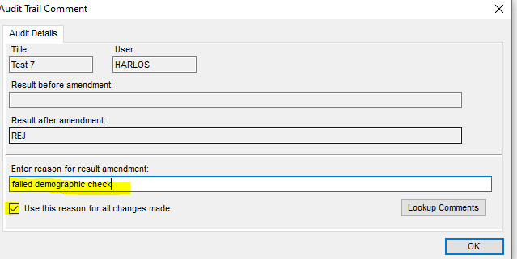

Then 

Find sample again on Patient/Request Entry. Click Results and then Amend.

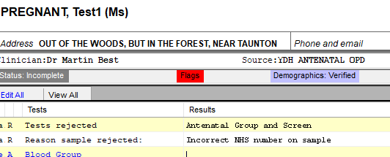As detailed previously use F4 or right hand click, text validation table, to select tests to reject and reason for rejection. Then Save

## Step 4. Centrifuge

Once the sample has been numbered and requested place straight into the Hettich rapid centrifuge (or conventional centrifuge if applicable, see above)

The next specimen can now be requested.

After centrifugation check the sample for integrity issues which prevent analysis:

* Sample volume should be a minimum of 1.0ml for automated analysis. Sample volumes of between 1-2mls should be run on the analyser but may subsequently be rejected due to insufficient sample for testing.
* Samples of less than 1 ml volume than this should NOT BE processed manually unless they are from a Neonate. These samples should be rejected and a repeat requested.
* Visibly haemolysed samples should not be run – reject the request and if appropriate telephone the originator for a repeat sample
* Clotted samples (taken into Red top (no additive) vacutainers) cannot be run – reject the request
* Samples containing a clot (but taken into an EDTA vacutainer) may be run provided the clot is fully removed and sufficient red cells remain for automated grouping.
* Processing of lipaemic samples should be attempted on the analyser. If lipaemia is gross automated interpretation of results may not be possible and manual editing will be required.

Place the samples for processing straight into sample rack for analysis or place rejected sample (due to integrity issues) into the rack for filing. See SOP TXS24 for details of how to file samples

# REGISTERING A PATIENT ON WPE

## Step 1: Check that a new registration is necessary

Before registering a patient as a new entry it is essential that you are sure that the details given are correct (Name, Hospital number, NHS number DOB). Details, with the exception of local hospital numbers, can be checked using the NHS Spine Care Summary Record (SmartCard), or alternatively by contacting the clinical area. The main reason for being unable to find an existing record is due to incorrect details being given, so a search should be done just of DOB to check for an entry with slightly different details, but recognisable as the same patient. If incorrect details are given on the request, the request should be rejected. If WPE (LIMS) is proven to be incorrect LIMS should be amended. WPE should never be amended unless assured that new details are correct.

## Step 2: For SMTC patients confirm details to be registered are correct on NHS Spine

Patients treated at SMTC (Practice Plus group) are frequently out of area and as such will have no records on our LIMS. If patient is to be registered use the NHS Spine (SmartCard) to confirm correct details before proceeding. If you do not have access to the NHS Spine leave the request for someone else who does. All SMTC patients will have a pre-op (first) sample and then a second sample prior to surgery, so if a patient needs to be registered this indicates this is a pre op request and surgery is not imminent.

## Step 3: For Non SMTC patients decide if it is clinically necessary to process the sample immediately

If a patient is not registered on LIMS it is often appropriate to wait for the patient to be registered centrally, to ensure that correct details are sent from a central point to all IT systems. If sample processing can wait it is appropriate to leave for 4-6 hours for registration to occur. If unsure if it is appropriate to delay processing please ascertain full clinical details from the ward (including likelihood of requiring blood) and then speak to a Transfusion Senior BMS for advice.

## Step 4: Actions required if deemed necessary to register a new patient

As stated previously, this should only be undertaken if a SMTC (Practice Plus group) patient or is clinically needed for patient care and checks have been made to avoid unnecessary creation of duplicate records

Instances where this may be necessary:

* Neonatal sample where result is required to issue anti-D to mum so that she can be discharged from hospital
* Blood or blood component issue on a new patient, including those admitted directly to Theatre from another hospital

If it is necessary to register a new patient on LIMS the reason for this should be investigated, ensure that a Senior BMS is informed during routine hours so that Pathology IT department can be contacted, and asked to investigate the circumstances.

Ensure that clear and correct demographics are available on the form and sample, if possible also confirm details on NHS Spine.



Search for patient with details given. If nothing found will say

then 

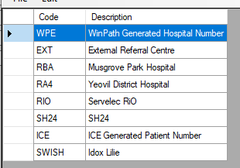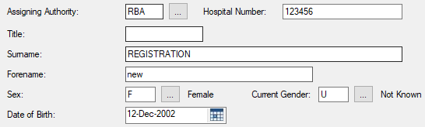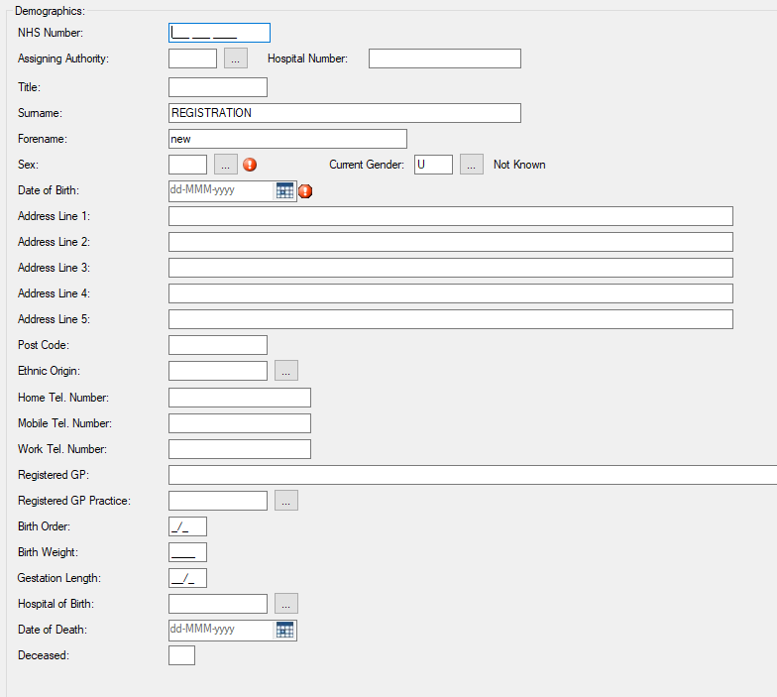It will take you to this screen. Enter all the details that you have. If NHS number given it can be added. If a hospital number given you will need to select the correct ‘Assigning Authority’

You cannot proceed without entering a hospital number

If you don’t have anything select WPE and put a number in the box. This is NOT a Unique ID number and cannot be used for blood issue



# PERFORMING DEMOGRAPHIC CHECK

In WPE all requests (those with samples and also those without) must have a demographic check performed. This should be performed by a BMS, and unless it is a period of lone working, this should be a different member of staff than the original requestor.

When rack can be removed the demographic check should be performed. Use batch verification:

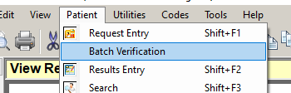

Wand in each sample and in conjunction with the request form ensure that sample and form meet sample acceptance policy. Either Verify the sample if you are satisfied that Sample meets acceptance policy or place in Hold if you wish to reject it. NOTE – this step should be done before results are released from BT analyser queue (see below)



# RELEASING RESULTS FROM BT ANALYSER

In WPE all tests are sent to BT Analyser. They must not be released from here until demographic check complete

Once results are approved and exported (if applicable, most will auto-approve and export) they are sent down to the

Authorisation queue.

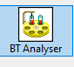 Unless a result has failed it should be possible to  all results to release them to the authorisation queue

# DETERMINING IF TWO SAMPLES ARE REQUIRED

To ensure patient safety (correct patient bled) it is a requirement that all patients (**with the exception of NEONATES**) have been tested for blood group on more than one occasion prior to issuing red blood cells (also platelets, and plasma components(FFP, Cryo)). The two separate samples for group and screen must both represent separate phlebotomy events and evidence of patient ID being confirmed. There is no maximum period after which the historical group is not valid (a sample from years ago is suitable provided the result is available on the LIMS, either associated with a sample, or as ‘legacy’ data take-on). On WPE when requesting if no historical blood group is displayed then a patient flag  will be added. 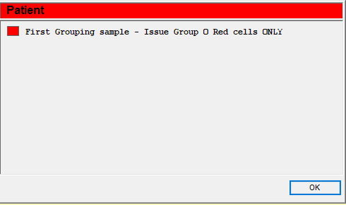

If blood requested on such a sample the clinical area should be telephoned and advised that a repeat is required before the laboratory will crossmatch any blood (unless an emergency)

Neonates may have blood issued on a single sample as Group O Neonatal ‘paedi’ packs only will be issued, and once the neonatal period (4 months) is over the infant would be treated like an adult and a further sample would be required every 72 hours for the provision of blood

# DETERMINING IF TWO SAMPLES REPRESENT SEPARATE VENESECTION EVENTS

Following discussion with the Transfusion Lead Consultant Haematologist the following has been agreed, and updated in January 2018, updated subsequently in March 22 and again in Jan 2023 with addition of collect label specifics:

* With implementation of sample collection using BloodTrack to generate specimen labels the declaration of phlebotomy section of the form no longer needs to be completed in these instances as all details of the phlebotomy event are held electronically. The declaration of phlebotomy detailed in below points may therefore be electronic or manual, depending on process used to take the sample
* Each sample must be accompanied by a separate request form and declaration of phlebotomy. Two samples with one form equals one sample.
* Ideally the samples should be taken by two different phlebotomists, although this is not mandatory
* Phlebotomy by one individual should be separated by a period of time to ensure that samples represent two separate phlebotomy events (two separate patient identification events). There is no minimum time difference, but they must be different.
* Alternatively two different people may take the samples at the same (for example in the scenario of an emergency patient with multiple cannula lines). Each sample must clearly be taken by a different person and be accompanied by a request form and declaration of phlebotomy.
* The laboratory staff will accept at face-value the information given by the person(s) signing the declaration or generating a BloodTrack sample. We will not be questioning or challenging the request as it is a clinical responsibility to correctly identify the patient.
* Any occasion of ‘split samples’ (taken at same time but split into two requests) should be raised as an incident and only one sample be tested, the other will be a reject. The clinical area should be phoned if the rejection will result in delay to emergency treatment
* Only in genuinely urgent cases would the laboratory proceed to issue blood with only one grouping sample, and only group O would be issued to ensure patient safety.
* Only a Consultant Haematologist can over-rule the requirement for a second sample (using a concessions form) in non-urgent situations, and as in other instances only group O would be issued.

# ‘COLLECT’ LABEL SPECIFIC ACCEPT V’S REJECT CRITERIA

Since the introduction of ‘collect’ labels it has been necessary to clarify when samples should be rejected as various anomalies have been encountered. Remember that the purpose of the sample acceptance criteria is the safety of the patient and ensuring correct patient identity. Professional discretion will need to be used, but you are not expected to ‘play detective’, especially if samples are arriving at separate times in the laboratory.

**However if there is doubt that the sample has been taken correctly as one continuous process and the label generated at the point of phlebotomy the sample should either be referred (Transfusion Senior or Consultant Haematologist) or rejected**.

Any anomalies in practice which lead to sample rejection should be feedback to the Transfusion Practitioner for re-education of the clinical areas

* Each sample must be accompanied by its own request form. Even if the form is not signed (as phlebotomy section is electronic)
* If the request form is also signed and dated this should match the collect label (a short time difference in label generation and declaration time is acceptable, maximum = 15 mins. The process should be one continuous uninterrupted event.
* Two labels generated at the same time only constitute one sample (as it is one phlebotomy event) (it is possible on Blood Track to see if labels were generated at the same time)
* Collect label does not match LIMS. Action required – determine which details are correct. We have had an instance where the patient had an incorrect wristband (wrong spelling of name) which was then used to generate a Transfusion collect sample. DO NOT assume the collect label is correct and amend the LIMS, always confirm directly with the clinical area/patient
* ***Collect labels should only be printed once (unless multiple samples are taken at same time, representing one phlebotomy event (for example to send to NHSBT)). Any instances of alteration of the BloodTrack label, including time of collection should be rejected. If two samples taken at the same time are received in separate request bags one should also be rejected as this represents a ‘split sample’ and not a second patient identity check***

Worked examples:

* Two samples in same bag, taken by same person but at different times = REJECT one sample
* Two samples in different bag, taken by same person but a different times (over a minute apart) = ACCEPT
* Two samples in different bag, taken by same person at same time = REJECT one sample
* Sample in a bag, collect label says one phlebotomist but form signed by someone different = REJECT (phlebotomist identity is in doubt)
* Two samples in a different bag, time of collection altered on one (or both of them) to make it look like a separate event = REJECT one sample
* Collect label printed greater than 15 minutes before(or after) the phlebotomy section says the samples were taken = REJECT
* Form not signed, collect label used on sample = ACCEPT (although ideally the form would also be signed by the phlebotomist)

# USE OF CONCESSION FORM (TXF83)

Information deemed essential is required on all transfusion requests (see above for details). Professional discretion is needed where minor errors have been made, e.g. Surname and forename have been inter-changed or DOB is missing from the form. A sample rejection may be overturned by a Consultant Haematologist, Transfusion Advanced Practitioner/Team Manager or Transfusion BMS. All concessions must be fully justified and kept to a minimum.

A ‘concession form’ (TXF83) must be completed to document the overturned rejection and scanned on the same laboratory number as the request form. In addition the request item ‘CONS’ must be added. The result field should be completed with a ‘*’ or initials of the signatory of concession form.

This acts as a permanent record of the nature of the problem and reason for concession and allows for audit of number of times a concession is applied.