INFORMATION SHEET

How to Order Andrology Tests via tQuest
GP Practices can now order Andrology tests electronically via tQuest.
Summary of Process
- Patient attends GP Practice
- GP creates electronic order for Andrology tests ‘GP Fertility Screen’
- GP indicates when ordering whether patient will deliver the sample to MPH or YDH
- GP types in the patient’s mobile phone number. This is important for contacting patient should the appointment change.
- The system will print out 2 labels – these are not required by the lab, but confirm that the electronic order has been successfully created on the system.
- The electronic order is transmitted to the lab immediately after the labels prints.
- The lab will process the electronic orders by sending out an appointment letter to the patient along with instructions. If the patient needs to change the appointment they are given the telephone number in the letter to phone to amend the appointment date.
- An Andrology specific cytotoxically tested sample pot is given to the patient by the GP Practice, these can be ordered from SPSStores@SomersetFT.nhs.uk
- If no appointment has been received within four weeks of the request being made, the patient should be instructed to leave a voicemail message on the Andrology telephone number: 01823 346702 stating their name and the name of the clinician who ordered the test, so that a duplicate communication can be sent.

Ordering Via tQuest
The Andrology tests can be ordered via tQuest using the “Test Groups” and looking under Andrology as shown in the screen shots below:
Find your patient in EMIS Web or other clinical system used at the GP Practice. Then use the usual method to start ordering pathology tests
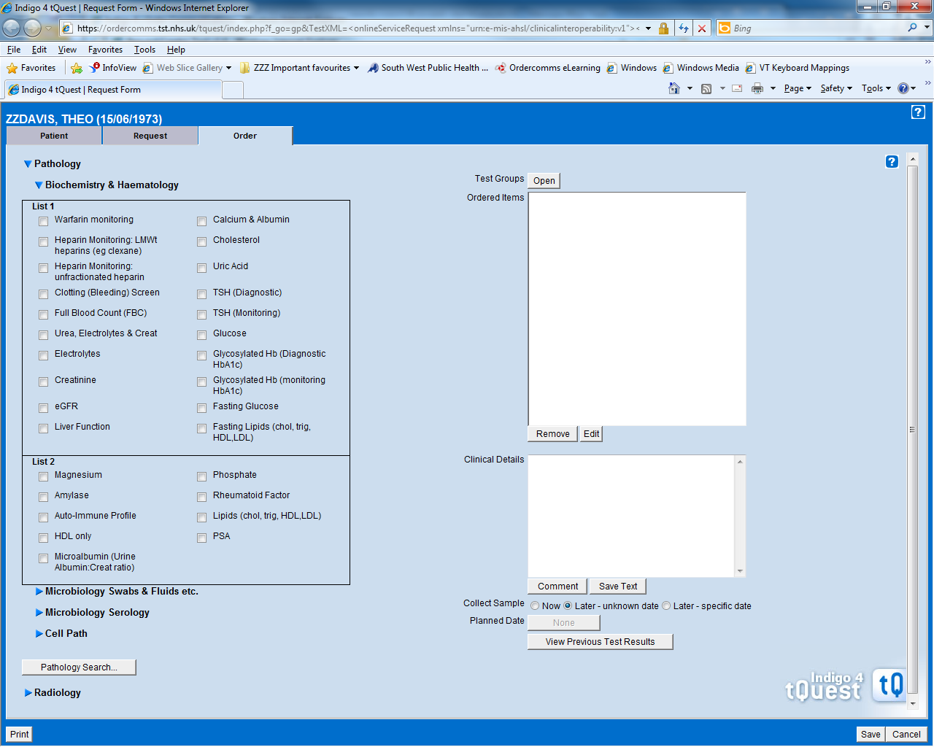
Click on the Test Groups button
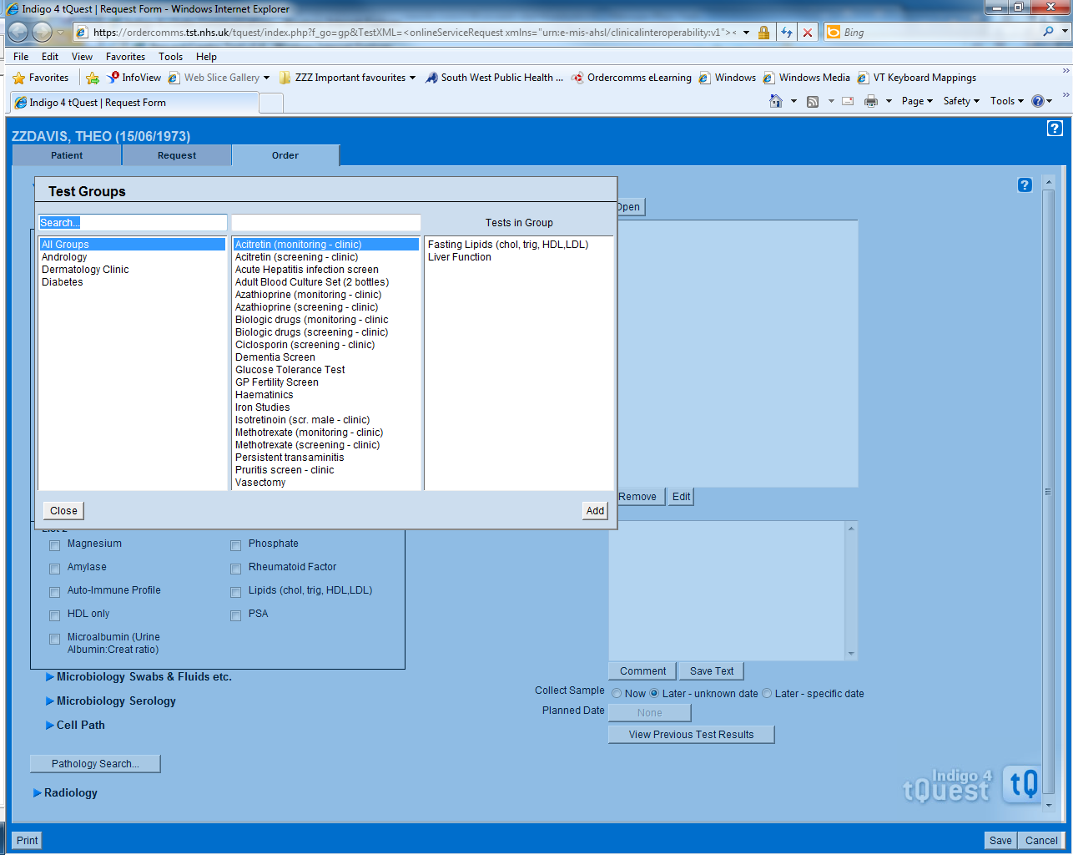
Click on the Andrology option

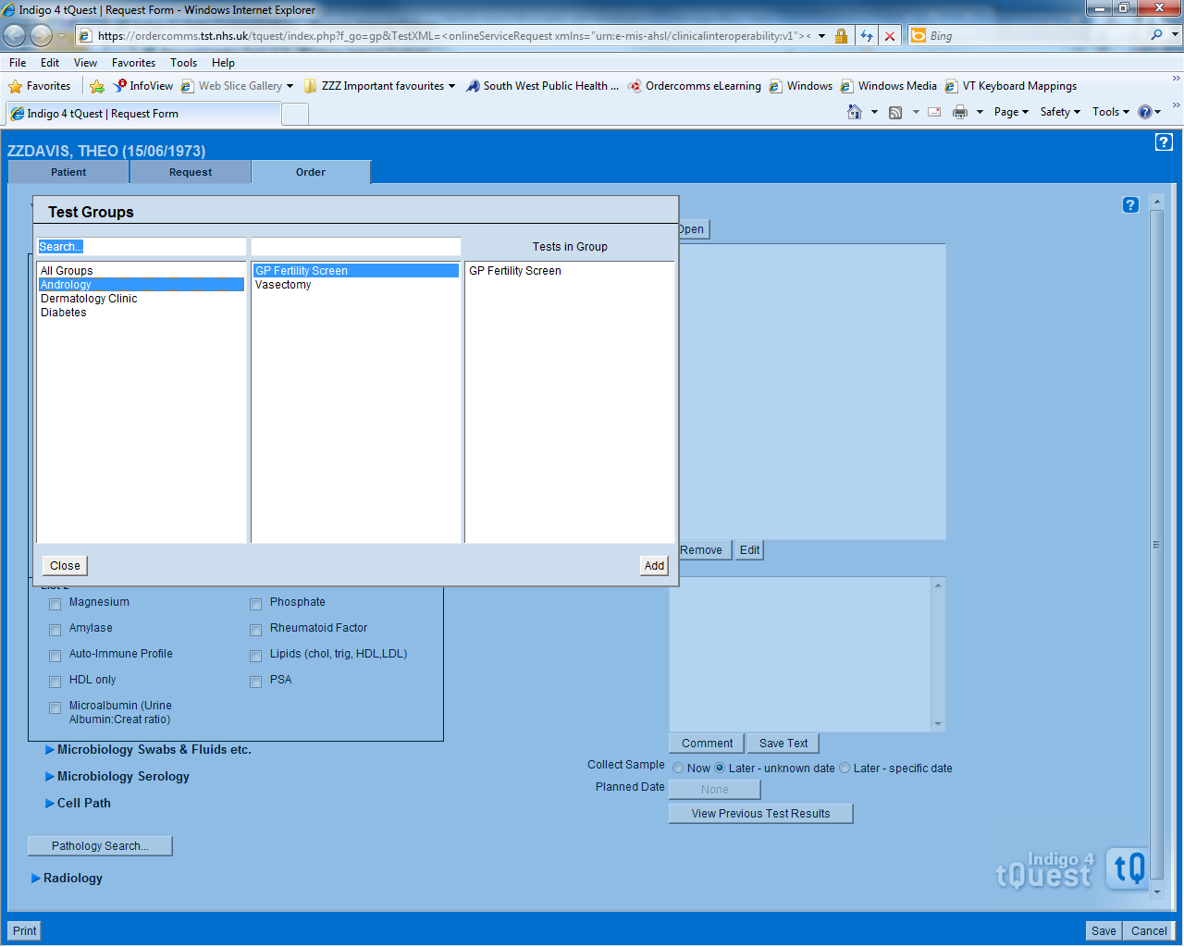
First select GP Fertility Screen by double clicking on the options in the middle column.
or
Single click and then click on the Add button.

Then click on the Close button

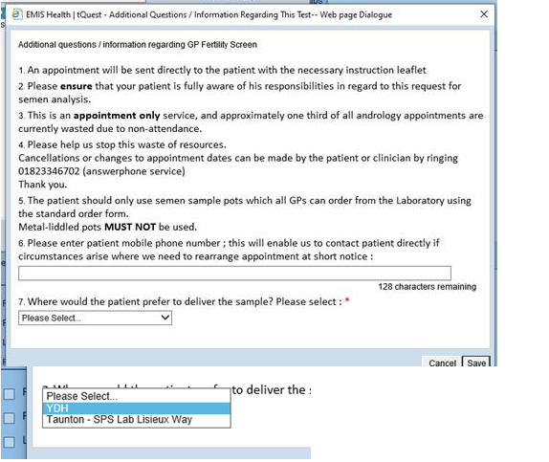
Please select which hospital the patient wishes to deliver the sample to.

Also enter the patient’s mobile telephone number.
Please select which hospital the patient wishes to deliver the sample to.

Plus please enter the patient’s mobile telephone number

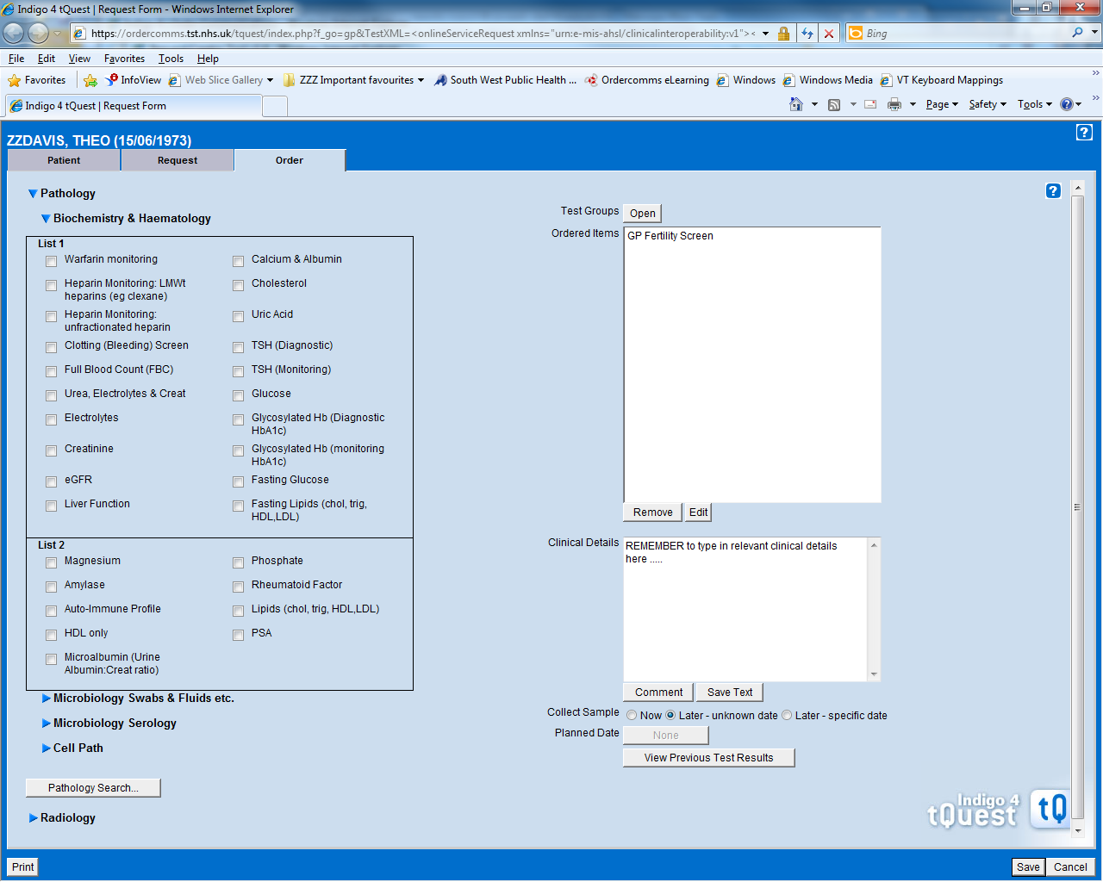
Please remember to enter partners name in Clinical Details field.

Click on the Print button to complete the order

