All samples received are labelled with a WPE number (in format YYT……., for example 24T10000433), this can be generated on ICE when being requested by the ward, or will be generated by WPE when booking in in the laboratory
Check through received work and divide into Urgent, Priority and Routine so that samples are requested in appropriate order. Ensure samples are at correct site – MPH process ALL antenatals, but all other YDH samples must be tested by the YDH ESL. Only one sample must be requested at a time, by the same individual
Check request form for essential elements (see below for current request form)
Complete all sections of the request form clearly & legibly – The form MUST contain at least 4 points of identification including a unique identity number (see SPS Sample acceptance policy for full details), ordercomms labels & patient note (addressograph) labels are acceptable on the request form but must not be used on the sample .The exception are ‘on-demand’ sample labels generated at the patient bedside by BloodTrack

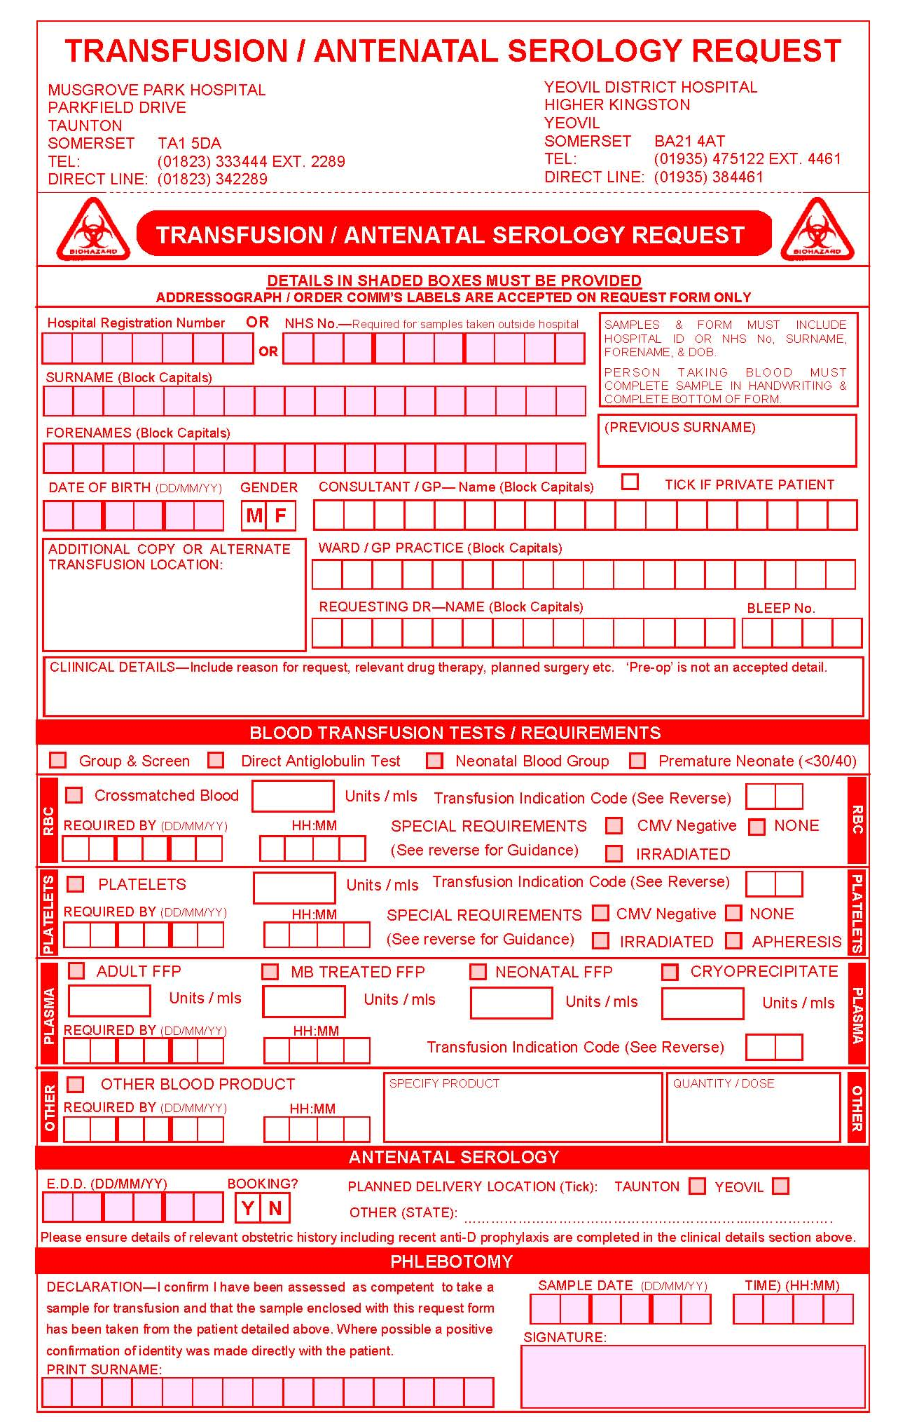

Ensure the requesting Consultant/GP is clearly indicated and the location of the request / transfusion has been given

Please indicate relevant clinical details including the date of surgery if applicable. This helps us to prioritise our work and inform you of potential problems

Please tick tests / products required & indicate how many units, special requirements & when the products are needed

Practitioner to complete – Any requests that are not signed here will be discarded. The exception are samples collected using BloodTrack where this information is recorded electronically
Please specify product requirements here.

Date & Time of collection to be completed by the person taking the blood sample –NB for BloodTrack samples this is recorded electronically

Date & Time of collection to be completed by the person taking the blood sample

Date & Time of collection to be completed by the person taking the blood sample
Please specify product requirements here.

Please indicate relevant clinical details including the date of surgery if applicable. This helps us to prioritise our work and inform you of potential problems

Remove sample from specimen bag and check that sample and form are identical.
Ensure request complies with SPS Policy (GGM1 and GGM2)
It is essential that the Transfusion sample is labelled with exactly the same details as the patient wristband, as it is the details on this wristband which MUST match exactly the compatibility label on any blood component or product issued by Transfusion
At MPH: The patient wristband is generated via MAXIMS. Currently Maxims may be updated by NHS Staff so can take into account ‘preferred’ names as declared by the patient. In light of a recent incident where patient preferred surname was changed on PAS but wristbands were not reprinted from MAXIMS it is important to check that the demographics being used match patient wristband and that if name is changed in PAS that new wristband is printed, and old one discarded. Future Transfusion requests would then need to use this new name and previous sample would not be suitable. The hospital number used on the wristband is the MRN (Musgrove number).The 2D barcode on the wristband must match the 2D barcode on compatibility labels, therefore is it essential that MRN numbers are used to request any sample that may lead to the issue of blood or blood components
At YDH: The patient wristband is generated via Trakcare, which is taken from the NHS Spine. The Trakcare number is a 7 digit ‘G’ number. The patient identification on the wristband, therefore matches NHS Spine record.
Essential information  Collect ( ‘on demand’ ) labels | Desirable information | Unacceptable  (requiring rejection)
‘On demand’ bedside generated sample label  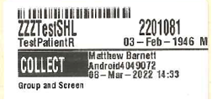  This label contains all the information required and is generated directly from patient wristband using BloodTrack  Note: Handwritten signature on sample is NOT required  Note: Phlebotomy section of form does not need to be completed as these details are held on BloodTrack (but ideally is still completed)  Details of any products required , requestor, location and clinical indication must be on the form, unless this is provided via use of a separate ICE request | Source of request  (Ward/Clinical area)  Clinical details | Alterations to BloodTrack label (including time of collection)  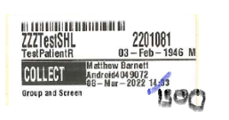
 | Source of request  (Ward/Clinical area)  Clinical details | Patient label /Addressograph label on sample – acceptable on FORM only  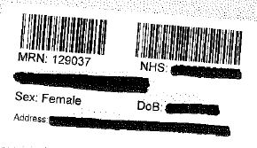
 | Source of request  (Ward/Clinical area)  Clinical details | ICE label on sample- acceptable on FORM only  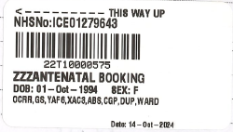
Somerset Nuffield ‘BARS’ labels are acceptable on the form and sample. These labels are generated at the bedside following venepuncture. A ‘TA’ number is generated which must be entered as an ‘EXT’ Number onto WinPath. | Source of request  (Ward/Clinical area)  Clinical details
Essential information  handwritten samples | Desirable information | Unacceptable  (requiring rejection)
The sample must be handwritten, but the form may be labelled using a patient label (addressograph) or ICE label providing all essential information is given as below |  | Sample not handwritten or illegible (smudged, smeared etc)
Unique identifying number  MRN (Musgrove number) essential at Musgrove for all requests that may lead to blood or component issue  NHS number preferred at Yeovil  Musgrove Park = Maxims (Musgrove) number  Yeovil = Trakcare (7 digit number ‘G’ number).  NB At YDH some outpatient samples may still arrive with 6 digit ‘H’ hospital numbers, but as this does not print on the wristband its use is to be discouraged. | Source of request  Requesting clinician  EDD (or weeks gestation) for antenatal requests.  Clinical details  Tests required | No Unique identifier (form or sample)  Incorrect spelling of surname/forename, abbreviations of names  Incorrect spelling of surname/forename, including abbreviations of names  No Signature of person taking blood (phlebotomy declaration)  No date of sample collection (obtained either from form or sample)  Crossed out or altered information where correct patient identity is questionable. (for example a different name has clearly been crossed out, as opposed to a correction of spelling of the same patient details)
Surname (correctly spelt) (as it appears on NHS Spine)
‘Preferred’ names, or alternative surnames (for example married v’s maiden name) can only be accommodated if the NHS Spine has been updated

Forename (as it appears on NHS Spine)
‘Preferred’ names, (for example Debbie v’s Deborah) can only be accommodated if the NHS Spine has been updated, and the hospital wristband has this preferred name

Signature of person taking the blood, including date and time of sample collection. This person does not have to be a Dr but must be aware that they are taking responsibility for the generation of a Transfusion request and sign the declaration
Date of birth

ICE label is acceptable and must be booked in using this Order.
Form must be signed by person taking the sample and sample handwritten

- If in doubt refer to main SOP, a senior member of staff, or request a repeat sample.
- Do not alter LIMS record unless you are absolutely sure data is correct.
- Professional discretion is still needed where minor errors have been made, e.g. Surname and forename have been inter-changed or DOB is missing from the form. A concessions form may be used in exceptional circumstances (TXF83)
- No Unique Identifier number may be acceptable in certain rare cases:
    - Vascular patients (1st line of address or Postcode acceptable)
    - Antenatal bloods on patients new to the country (1st line of address acceptable)
    - Newborns following a home-birth (1st line of address acceptable)
    - Officers from 40 CDO (Norton Manor Camp) (40 CDO acceptable as address)

For information on what to do if patient not registered on LIMS please see main SOP

IMPORTANT AMENDMENTS DUE TO IMPLEMENTATION OF BLOODTRACK AND ICE

ICE GENERATED REQUESTS FOR TRANSFUSION

The clinical areas can use ICE to generate requests, including Transfusion. This includes routine tests and also blood and blood product requests. Note Neonatal (Baby) group and Kleihauer can only be requested if patient demographic is applicable to that test
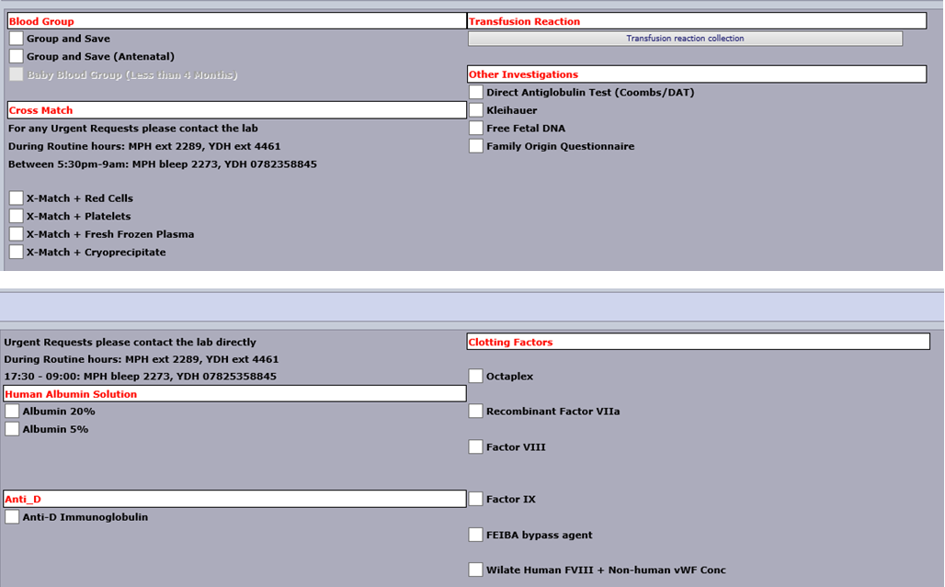
An ICE generated request will come with an ICE label on the form, but sample must still be handwritten (or can be a Blood Track Collect label (see later section)

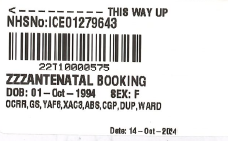ICE label – Form ONLY

REQUEST USING MRN: APPLICABLE TO MUSGROVE SITE ONLY
For scanning of patient identification 2D barcodes printed on the compatibility label and linking this up with the patient wristband it is important that all group and screens which may lead to a request for blood or blood components are requested using the hospital number (Medical Record Number or MRN) . This applies even if the hospital number is NOT used on the sample.
For all requests which may lead to a component issue:
- If MRN is on the sample use this to request the sample
- If NHS number is on the sample and both MRN and NHS is on the form confirm that NHS number is correct but use the MRN (from form) to request the sample
- If NHS number is on the sample and form and MRN is not on form it will be necessary to look up the patient record on LIMS, write down the MRN from the patient record and then use this to request the sample
The Transfusion Team appreciate that this is a deviation from previous process but is necessary to ensure that any component issued can have label verification performed before release to the issue fridge and can be transfused to the patient without an alert sounding on BloodTrack which prevents it.
NB: This is not applicable to Antenatal requests which do not lead to component issue
NB: This is not applicable to Yeovil where NHS number is used on the patient wristband and therefore is the MRN

‘ON DEMAND’ SAMPLE LABELS PRINTED AT PATIENT BEDSIDE ACCEPTABLE ON SAMPLES

At Musgrove Park Hospital only BloodTrack TX can be used to generate labels for blood transfusion sample tubes. A handheld PDA device is used to scan the patient wristband and this information is used to print a label for the sample tube as one continuous process at the patient bedside. The collect label will therefore always match the patient wristband
Bedside PDA and printer

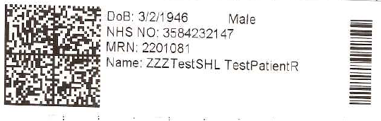
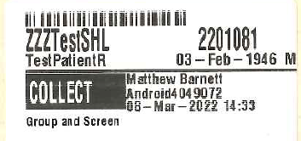
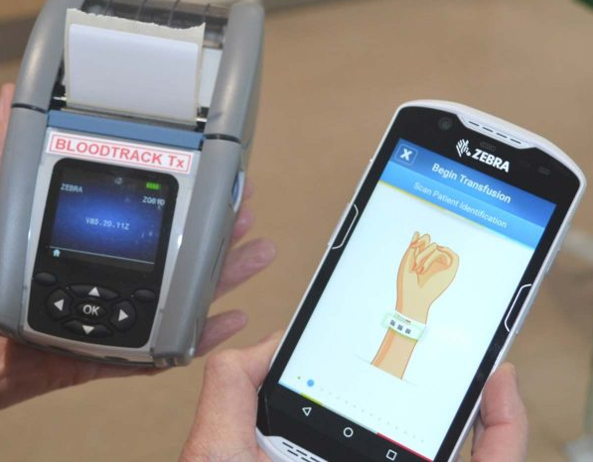
Patient wristband
Label for sample tube – Note ‘COLLECT’ field detailing who collected and date and time. This information is held on BloodTrack and is fully auditable
These labels contain all the required details and are acceptable on the sample tube. There is no requirement to handwrite any additional information on the sample tube. There should be no alterations on the collect label. Multiple labels printed at the same time can only be used to label tubes if they represent a single phlebotomy event.

Not to be confused with normal ‘addressograph’ sample labels which are NOT acceptable on samples
Or ICE labels which are NOT acceptable on samples
- Only a Consultant Haematologist can over-rule the requirement for a second sample (using a concessions form) in non-urgent situations, and as in other instances only group O would be issued.

Once form and sample have been checked to ensure essential information has been completed proceed to Step 3

Request on LIMS
- ICE request
Form will come labelled with an ICE request number
Log into WPE. Select BT. Request Entry

Using barcode scanner enter the lab number 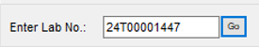, and then again in the 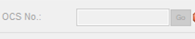 field

Check all demographics brought up match your patient sample. For an OCS order the clinician, source, clinical details will be completed. If the requestor has generated a request on a pregnant patient the EDD or weeks gestation will be completed. There may also be information in this line

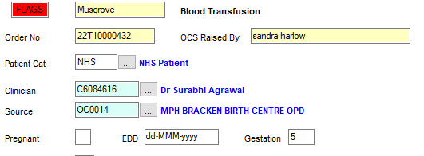
You will still need to choose the correct category and print a label for the sample (see later)

- Non ICE request

Log into WPE. Select BT: Request Entry

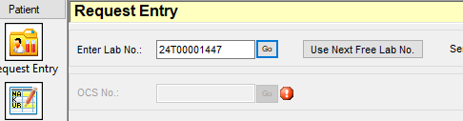

Use Next Free Lab No and Go. Next number will be assigned. Then click 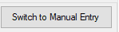
Enter Unique ID number (NHS or MRN) from the sample to search for the patient. Check all demographics match your patient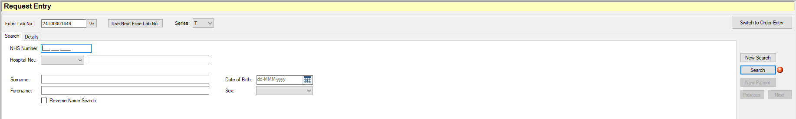
Check all demographics match your patient sample. You will need to complete all the highlighted fields, see below for details of category
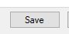
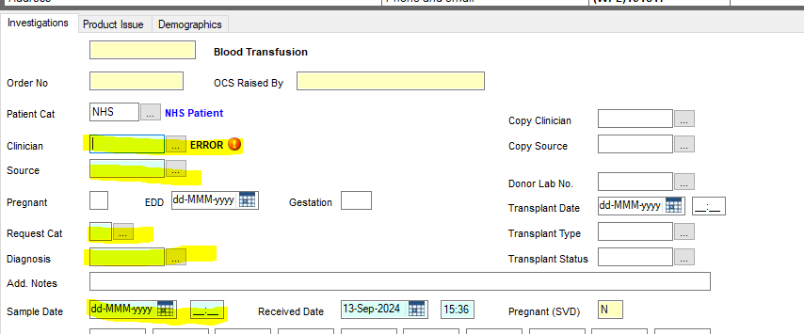
Once all fields have been completed (see below for details on Request category) click, routine group and screen will be added (These do not need to be added by the requestor)
If you require additional tests (for example RHK, MONO, Neonatal DAT) they can be requested by putting the correct request code in the TESTS box. See Information Sheet TXA28 for list of request codes

Printing label for sample and/or form

In requesting screen click icon at top 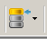

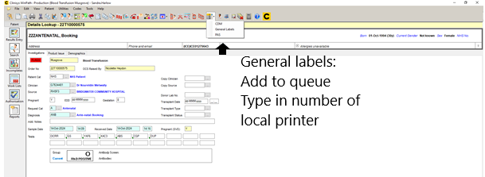
Printer number will be displayed on the ZEBRA printer. Two labels will print, attach to form and sample. If one label is not required discard it

Selection of correct category
WPE uses request categories to determine which group and antibody screen TFC’s (request items) to add

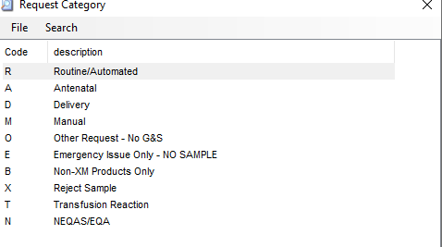

For routine group and screens the category is R, for antenatals it is A. For further details on Antenatal requesting refer to SOP TXS57
A different request category exists for delivery bloods, this is for the ‘Post Natal Fetal Leak’ requests only.

HANDLING OF SAMPLE REJECTS

Rejected requests at original sample entry
If request fails sample acceptance policy it should be rejected. Request as per usual requesting procedure, choosing category X.
It will be necessary to perform demographic check (even though it has been rejected).
Click 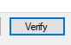
Then 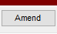 to go into screen where you can put results in
In ‘Tests Rejected’ box either F4 to get list of test rejected or right click, Text validation table to get list
Choose which test you are rejecting, and then reason for rejection
You will then need to authorise via the failed queue/sample rejects

To reject sample after it has been requested (for example due to failure of demographic check) refer to main SOP
Once the sample has been numbered and requested place straight into the Hettich rapid centrifuge (or conventional centrifuge if applicable due to being a small sample)

Place the samples for processing straight into sample rack for analysis or place rejected sample (due to integrity issues) into the rack for filing. See SOP TXS24 for details of how to file samples

PERFORMING DEMOGRAPHIC CHECK
In WPE all requests (those with samples and also those without) must have a demographic check performed. This should be performed by a BMS, and unless it is a period of lone working, this should be a different member of staff than the original requestor.

When rack can be removed the demographic check should be performed. Use batch verification:
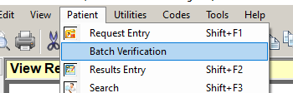
Wand in each sample and in conjunction with the request form ensure that sample and form meet sample acceptance policy. Either Verify the sample if you are satisfied that Sample meets acceptance policy or place in Hold if you wish to reject it. NOTE – this step should be done before results are released from BT analyser queue (see below)
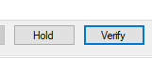

RELEASING RESULTS FROM BT ANALYSER
In WPE all tests are sent to BT Analyser. They must not be released from here until demographic check complete
Once results are approved and exported (if applicable, most will auto-approve and export) they are sent down to the

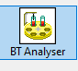 Unless a result has failed it should be possible to 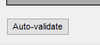 all results to release them to the authorisation queue

DETERMINING IF TWO SAMPLES ARE REQUIRED

To ensure patient safety (correct patient bled) it is a requirement that all patients (with the exception of NEONATES) have been tested for blood group on more than one occasion prior to issuing red blood cells (also platelets, and plasma components(FFP, Cryo)). The two separate samples for group and screen must both represent separate phlebotomy events and evidence of patient ID being confirmed. There is no maximum period after which the historical group is not valid (a sample from years ago is suitable provided the result is available on the LIMS, either associated with a sample, or as ‘legacy’ data take-on). On WPE when requesting if no historical blood group is displayed then a patient flag 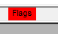 will be added. 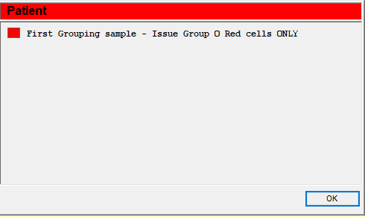
If blood requested on such a sample the clinical area should be telephoned and advised that a repeat is required before the laboratory will crossmatch any blood (unless an emergency)
Neonates may have blood issued on a single sample as Group O Neonatal ‘paedi’ packs only will be issued, and once the neonatal period (4 months) is over the infant would be treated like an adult and a further sample would be required every 72 hours for the provision of blood

For additional information on ‘two sample rule’ and specifics relating to Collect labels please refer to main SOP

