Direct Antiglobulin Test 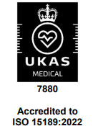
Synonyms |  |  | DAGT, DCT, DAT, Direct Coomb's Test, Coomb's Test
Clinical Indication |  |  | Laboratory screening results suggest follow up test and/or Consultant direction. Examples; haemolytic anaemia, possible transfusion reaction, haemolysis screen. Cord specimens NO LONGER require a DAGT test as part of the Cord & Maternal Testing.  On clinical indication only with guidance from a Consultant Haematologist
Part of Profile / See Also
Request Form |  |  | Combined Pathology manual Blood form or ICE request
Availability / Frequency of Analysis |  |  | On request.
Turnaround Time |  |  | 24 Hrs
Patient Preparation
Sample Requirements
 | Specimen Type |  | Whole Blood
 | Volume  Container  Basildon Site:  Southend site: |  | Patient > 4 months old up to age 12: 1 x 2 ml EDTA sample, bled into 4 ml EDTA sample tube  Patient > 12 years old and up to adult: 1 x 4 ml EDTA sample.  Patient < 4 months old, 1 x 1ml EDTA sample: bled into paediatric sample tube  Purple top (EDTA) tube.  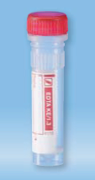  Sarstedt EDTA KE/1.3 Micro tubes with red screw cap  Purple Top (EDTA) tube  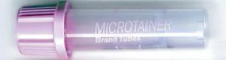  Pink Top EDTA (Microtainer)
 |  |  | Samples must be labelled in full and signed by person collecting the blood, in accordance with the Blood Transfusion specimen acceptance policy. Samples must be transported to the laboratory immediately.
Reference Range & Units |  |  | Refer to individual reports.
Interferences |  |  | False-positive or false-negative test results can occur from bacterial or chemical contamination of test materials, improper centrifugation or improper storage of materials.  Anomalous results may be caused by fresh serum or fibrin or particulate matter in plasma.  Not all positive reactions imply the presence of clinically significant antibodies. To further investigate positive results elution techniques may be used.
Interpretation & Clinical
Decision Value (if applicable)
References
Test code
Lab Handling |  |  | Samples are spun before processing.

