

SHBG |  | 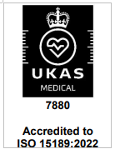
Synonyms |  | Sex Hormone Binding Globulin
Clinical Indication |  | SHBG is the major serum testosterone binding protein and binds over 70% of testosterone. SHBG levels are suppressed by increased androgen levels and elevated by increased oestrogen (e.g. during pregnancy or treatment with some oral contraceptives). The primary reason for measurement of SHBG is to calculate free androgen status from total testosterone levels and is useful if total testosterone levels are borderline. SHBG levels are not helpful in discriminating between groups of patients with suspected androgen excess.  SHBG levels are elevated in thyrotoxicosis and decreased in hypothyroidism and SHBG may be used as a marker of thyroid status in patients with thyroid hormone resistance.  Female total testosterone greater than 1.5 nmol/L or borderline/low male testosterone. Assessment of thyroid status in thyroid hormone resistance. Otherwise if requested by Consultant Endocrinologist or agreed with Consultant Biochemist.
Part of Profile / See Also
Request Form |  | Combined Pathology manual Blood form or ICE request
Availability / Frequency of  Analysis |  | On request
Turnaround Time |  | Same day (weekdays only)
Patient Preparation |  | None required.
Sample Requirements
Specimen Type |  | Serum or plasma
Volume |  | 2 mL
Container
Gold-top (SST) tube

Or

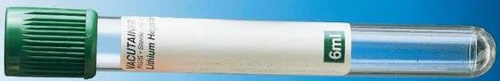 Green-top (lithium heparin) tube

Plain serum samples may also be used

Reference Range & Units
 | Patient group | SHBG (nmol/L) | Source
 | Male: < 30 days | 12 – 116 | Caliper study
 | Male: 1 – 12 months | >32
 | Male: 1 – 7 years | 53 - 174
 | Male: 7 – 10 years | 45 – 144
 | Male: 10 – 12 years | 16 – 132
 | Male: >12 years | 13 - 90
 | Female: < 30 days | 12 – 116
 | Female: 1 – 12 months | >32 | Caliper study
 | Female: 1 – 7 years | 53 - 174
 | Female: 7 – 10 years | 45 – 144
 | Female: 10 – 12 years | 16 – 132
 | Female: 12 - 46 years | 18 – 136
 | Female: >46 years | 17 - 125
If total testosterone is measured a free androgen index (FAI) will be
calculated and reported.
 | Patient group | Free Androgen Index (nmol/L)
 | Male: > 17 years | 24 – 110
 | Female: 16 – 46 years | < 11
 | Female: >46 years | < 7
Reference: Beckman kit insert

Interferences
N/A
Interpretation & Clinical Decision Value (if applicable)
References
Test code
SHBG
Lab Handling Analysed from primary tube and stored at 4°C.

