Insulin
Synonyms
Clinical Indication |  |  | Insulin is released by the pancreatic B-cells in normal response to rising circulating glucose.  In the differential diagnosis of documented spontaneous hypoglycaemia; Insulin is measured alongside c-peptide and can be used to indicate either insulinoma (both insulin and c-peptide are raised) or exogenous insulin administration (insulin may be high depending on cross reactivity of exogenous insulin but c-peptide will be low). In these cases, samples will not normally be analysed unless simultaneous glucose analysis shows hypoglycaemia (,2.5 mmol/L by laboratory assay).  The use of insulin and C-peptide levels to assess endogenous insulin production in Type 2 diabetics is unreliable and should be restricted to patients awaiting renal/pancreatic transplant.
Part of Profile / See Also
Request Form |  |  | Combined Pathology manual Blood form or ICE request
Availability / Frequency of Analysis |  |  | Referred test: If specific criteria is met, insulin is analysed by Synnovis Hub Laboratory, London.  www.synnovis.co.uk/our-tests/insulin
Turnaround Time |  |  | 1 week if discussed with a Biochemist, assay is only run once a week at the referral laboratory. Up to 2 weeks for routine requests.
Patient Preparation |  |  | For investigation of hypoglycaemia, a grey top (fluoride) sample must be taken simultaneously.
Sample Requirements
 | Specimen Type |  | Fasting serum (EDTA plasma also acceptable)
 | Volume |  | 2 ml
 | Container |  | 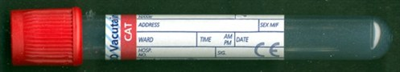 Red top serum tube  or   Yellow top (SST) tube  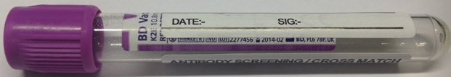 Large purple top (EDTA) tube  Or 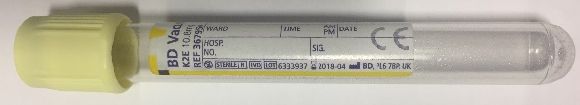 Lemon top (EDTA)  Or 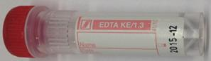 Paediatric EDTA (Red top – Sarstedt)  Paediatric EDTA (Pink top – BD Microtainer)  If being used in the context of hypoglycaemia, a glucose sample (grey top) must be measured in the laboratory at the same time to confirm that the patient is hypoglycaemic.  Send samples to the laboratory for processing as soon as possible.
Reference Range & Units |  |  | No reference range is provided by the referral laboratory.  Units of measurement are pmol/L
Interferences |  |  | Haemolysis interferes with the insulin method – haemolysed samples will not be sent.  The Abbott Alinity method in use at Synnovis may cross react with exogenous insulin preparations: interpret results with caution.
Interpretation & Clinical
Decision Value (if applicable)
References
Test code |  |  | INS
Lab Handling |  |  | Separate an aliquot (at least 500ul) ASAP and store in the frozen referrals rack at -20C. Samples are sent frozen by Global courier.

