Sirolimus
Synonyms |  |  | Rapamycin, Rapamune, Sir
Clinical Indication |  |  | Sirolimus is an immunosuppressive drug licensed for use in renal transplantation.  Sirolimus exerts its effect by inhibiting the activation of T and B cells. It is important to monitor the blood concentration of sirolimus as at toxic concentrations patients are susceptible to a number of side-effects. At sub-therapeutic dosage, patients may experience transplant rejection.
Part of Profile / See Also
Request Form |  |  | Combined Pathology manual Blood form or ICE request
Availability / Frequency of Analysis |  |  | Referred test: Analysed by the IMS Laboratory, King’s College Hospital Synnovis 8805.
Turnaround Time |  |  | 48 hours (up to 4 days if sample is received on a Friday or over the weekend)
Patient Preparation |  |  | Trough sample required: 2 - 4 hours before next dose.
Sample Requirements
 | Specimen Type |  | EDTA Whole Blood
 | Volume |  | 2mls minimum
 | Container |  | 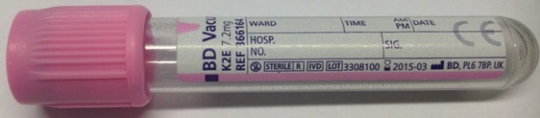 Pink/purple top (EDTA) tube  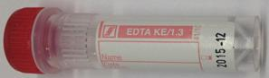 Paediatric EDTA (Red top – Sarstedt) 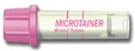 Paediatric EDTA (Pink top – BD Microtainer)
Reference Range & Units |  |  | ug/L. Therapeutic range varies depending on reasons for use, type of transplant and concomitant disease and medication. See www.sirolimus.org.uk
Interferences
Interpretation & Clinical  Decision Value (if applicable) |  |  | No established therapeutic range. Please contact the reference laboratory if you wish to discuss a result (07738 897225 / 02071 889652)
References |  |  | http://www.viapath.co.uk/our-tests/sirolimus
Test code |  |  | SIRO
Lab Handling |  |  | 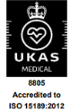  Store the whole blood (EDTA) in the referrals rack at 4°C. Sent daily by courier to King’s College, London.

